**Introduction to Statistics**

1. **Are respondents feeling better (cf. mood) after eating chocolate?**

We need to compare two means: **mood before and mood after eating chocolate**. Same respondents took part in both conditions, and hence we will perform **Paired samples T-test.**

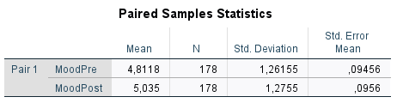

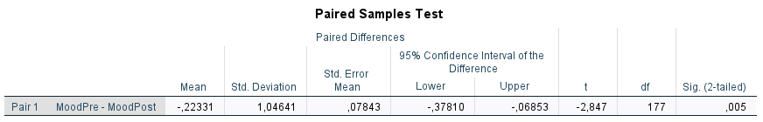

In the paired samples test table, we can observe that the means between mood of the participants before and after eating chocolate are significant different. (P-value <0.005). Thus, participants show significantly better mood (Happy/Good Mood/Pleased/Cheerful) after chocolate tasting (**M=5.03, SD = 1.28**) than before tasting chocolate (**M=4.81, SD = 1.26; t(177) = -2.85, p = 0.005**). Hence, our hypothesis is correct and we can say that respondents are actually feeling better after eating chocolate.

1. **Are respondents evaluating the taste of mass market, premium and super premium chocolate brands differently?**

We need to compare the means of taste evaluation for the three different types of chocolate brands. So, we need to use One-way ANOVA procedure, since we will comparing more than two means and we have independent samples.

First, we will check ANOVA table to see if there is significant different between the means of each group to proceed with the further analysis. In this case ANOVA **< 0.05**, so we proceed with the rest of the results.

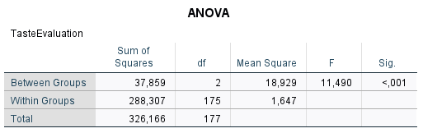

Now, we should evaluate if the variances among the three groups are equal by checking the below table (**Test of Homogeneity of Variances**)

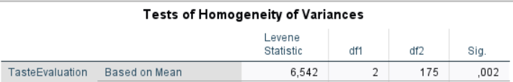

The hypothesis testing with the previous test is:

H0= the variance of taste evaluation between the three groups are equal

H1= the variance of taste evaluation between the three groups are not equal

We can conclude from the above table that the variance between the groups are not equal because p-value= **0.002** thus the hypothesis null is rejected and we should use the test the **Dunett’s test T3**.

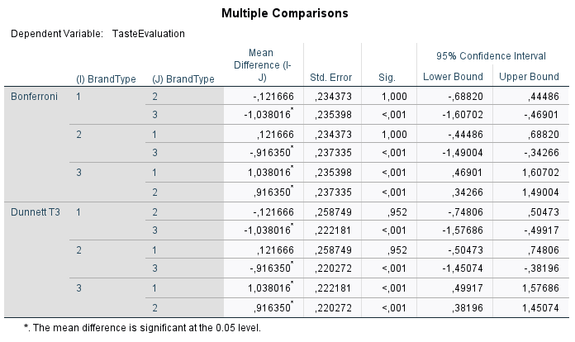

From the previous table, we can observe that the group 3: **Premium Brand** is significant different from groups 1 and 2: Mass Brand and Super Premium Brand. The p-value in these cases are p <0.001.

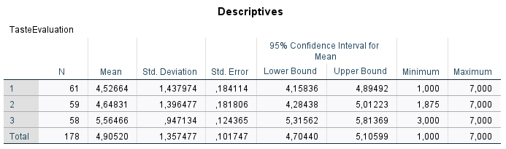

There is a significant effect of the type brand surveyed on the taste evaluation given (F(2,175) =11.50, p<0.001)). **Dunnett’s T3** post-hoc tests show that tasting premium chocolate lead to significantly higher test evaluation score (**M=5.56, SD = 0.95**) compared to tasting mass brand chocolate (**M = 4.53, SD=1.44; p <0.001**), or tasting super premium chocolate brand (**M=4.65, SD= 1.40; p <0.001**). Hence our hypothesis is correct and we can say that respondents are evaluating the taste of mass market, premium, and super premium brands differently.

1. **Is the taste evaluation different for milk and dark chocolate?**

Here we will be comparing two taste evaluation means, one for milk and one for dark chocolate, and given the fact that we have independent sample because there are different respondents who took part in both conditions and hence we will use **Independent – Samples T-test**.

First, we need to check if there is difference among the variances, we found that **p > 0.05**, by looking at the first row of equal variances assumed of the independent samples test table.

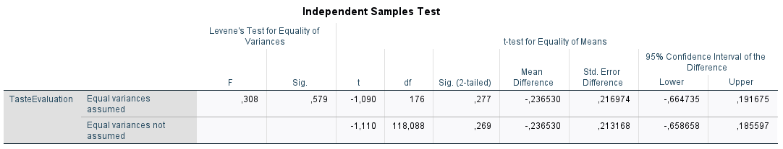

Looking at the 1st row equal variances assumed, we can conclude that there is not significant difference between the means of the two groups since p-value>0.05.

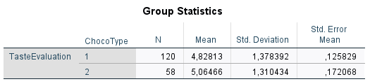

Tasting milk chocolate (**M = 4.83, SD = 1.38**) does not lead to a higher or lower score in the taste evaluation compared to tasting dark chocolate (**M=5.06, SD =1.31, t(176) = -1.090, p = 2.77**). Hence, we can conclude that the taste evaluation is not different for milk and dark chocolate.